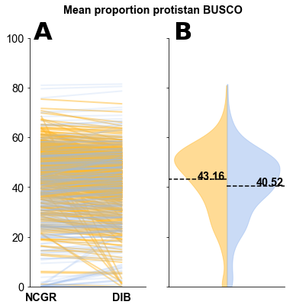

Supplemental Figure 3. The mean proportion of contigs with complete protistan universal single-copy orthologs (BUSCO) recovered in each assembly. (A) Line plots compare values between the DIB and the NCGR ‘nt’ assemblies. Red lines represent values where NCGR ‘nt’ assemblies were higher than the DIB re-assemblies and green lines represent values where the DIB re-assemblies were higher than the NCGR ‘nt’ assemblies. (B) Split violin plots show the distribution of protistan BUSCO scores for each, in the blue (right side) are the “DIB” re-assemblies and in yellow (left side) are the original assemblies from NCGR ‘nt’ assemblies.